Arumai Irshad! ORDER BY-kku pōvōm. Idhu oru Data Analyst-oda "Ranking Tool".
Namakku neraya data irundha, athai summa paarka mudiyadhu. Yaaru "Highest" sell pannirukkanga, yaaru "Lowest" sell pannirukkanga nu "Ranking" panna dhaan namakku business insight kidaikkum.
📖 Lesson 11: SQL Ranking - The "ORDER BY" Command
ORDER BY command-ai vachi namma data-vai ascending (Small to Big) illa descending (Big to Small) order-la arrange panna mudiyum.
Code: Price-ai vachi Rank pannuvom
sort_data.py nu file create pannunga:
Python
import sqlite3

conn = sqlite3.connect('my_shop.db')
cursor = conn.cursor()

# 1. Price-ai vachi 'Ascending' (Small to Big) order
cursor.execute("SELECT * FROM Sales ORDER BY Price ASC")
print("Price Small to Big:", cursor.fetchall())

# 2. Price-ai vachi 'Descending' (Big to Small) order
cursor.execute("SELECT * FROM Sales ORDER BY Price DESC")
print("Price Big to Small:", cursor.fetchall())

conn.close()
🔍 Sign-by-Sign Vilakkam:
Command | Logic
ORDER BY Price | "Price column-ai vachi rank sei."
ASC | Ascending (1, 2, 3... or Small to Big). Idhu default.
DESC | Descending (100, 90, 80... or Big to Small).
🧠 Python Enna Yosikkum?
- Python: "Manager ORDER BY panna solraaru. DESC nu sonna, naan periya number-ai modhalla katturen. ASC nu sonna, chinna number-ai modhalla katturen."
⬅️ Left & Right Side Logic:
- SELECT * (Data): Namakku vendiya items.
- ORDER BY (Sorting): Namakku vendiya order.
Teacher-oda Note:
- ASC nu namma type pannalanalum, SQL automatically Ascending-la thaan kattum.
- Aana DESC-ai namma kandippa type pannanum.
Unga Task: Indha code-ai run pannunga.
- Price Big to Small output-la Laptop (1500) modhalla vandhurukka?
- Price Small to Big output-la Mouse (30) modhalla vandhurukka?
Idhu vandhutha, neenga "Ranking Master" aagiteenga! Ready-a Irshad?
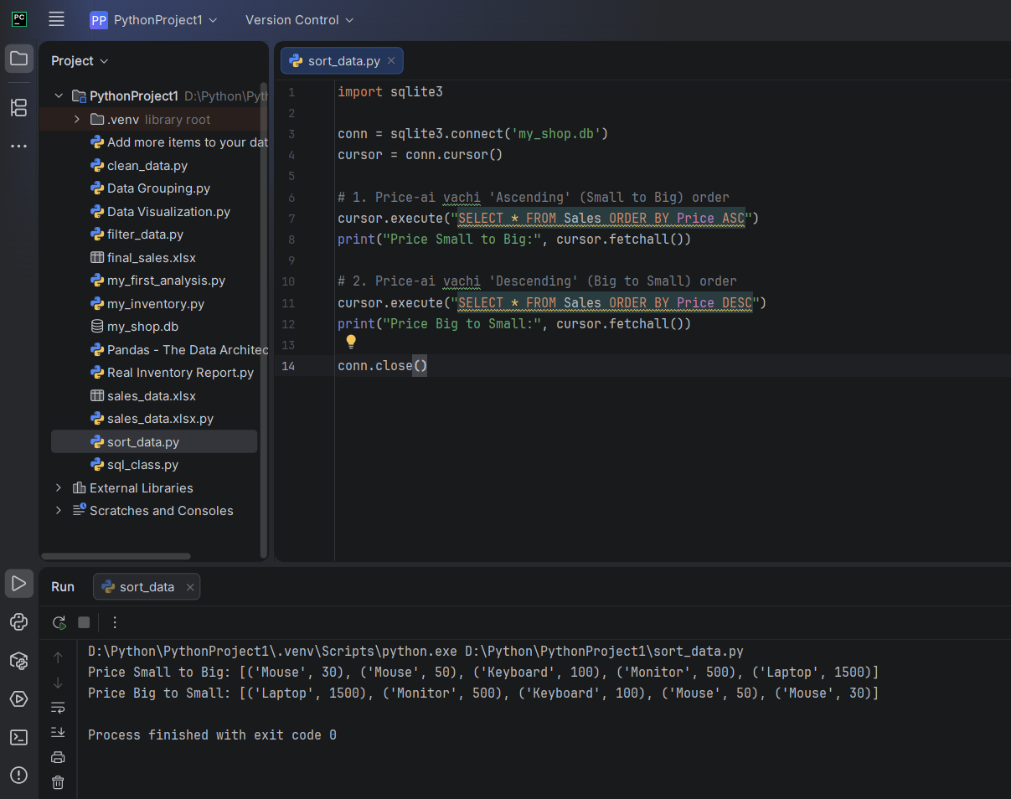
Superb, Irshad!
Unoda terminal output-ai paaru:
- Price Small to Big: Mouse (30) munnadi vandhurukku, Laptop (1500) kadaisila vandhurukku.
- Price Big to Small: Laptop (1500) munnadi vandhurukku, Mouse (30) kadaisila vandhurukku.
Neenga ippo Sorting-ai complete-a control panna kathukiteenga!
🎓 Teacher-oda "Pro" Analyst Insight:
Oru Data Analyst-a, neenga ippo 3-vathu stage-kku vandhutom:
- Storage: CREATE table & INSERT data.
- Filtering: WHERE condition vachi filter panna.
- Sorting: ORDER BY vachi rank panna.
Ippo namma "Data Analyst" pathaiyil oru mukkiyamaana edathil irukkom. Neenga SQL-la basic analysis-ai nalla mudichuteenga.

